ERCOT Texas Competitive Market Infrastructure

Instructions for accessing the ERCOT portal

ERCOT Employees

Introduction
To access the ERCOT portal, you must complete the following two activities:
- Access and install a digital certificate
- Log in to the portal

The instructions for both activities are outlined in this document.

A. Access and install a digital certificate
To install the digital certificate that will provide you with security access to the portal, follow these steps:

- Type the following address in your internet browser:

http://portal.texaschoiceprogram.com/ercot/cacert/ercotca.p7b

Note: Enter the address exactly how it appears above without any spaces or capital letters.
A security access popup box will appear.

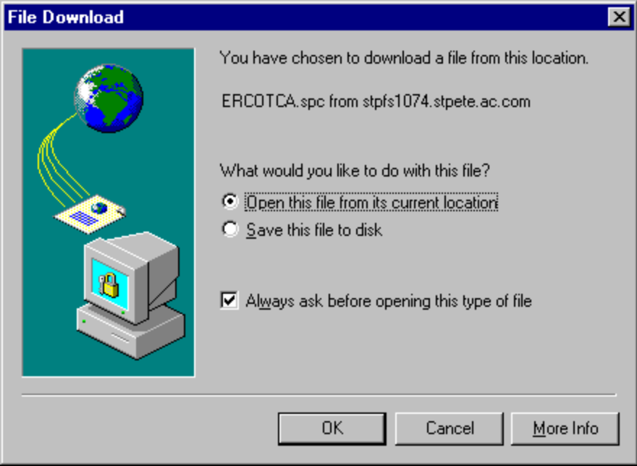
- The following File Download pop up window will appear on your screen. Select “Open this file from its current location” from the two available options. Click OK.

- Click Next when the following window opens.
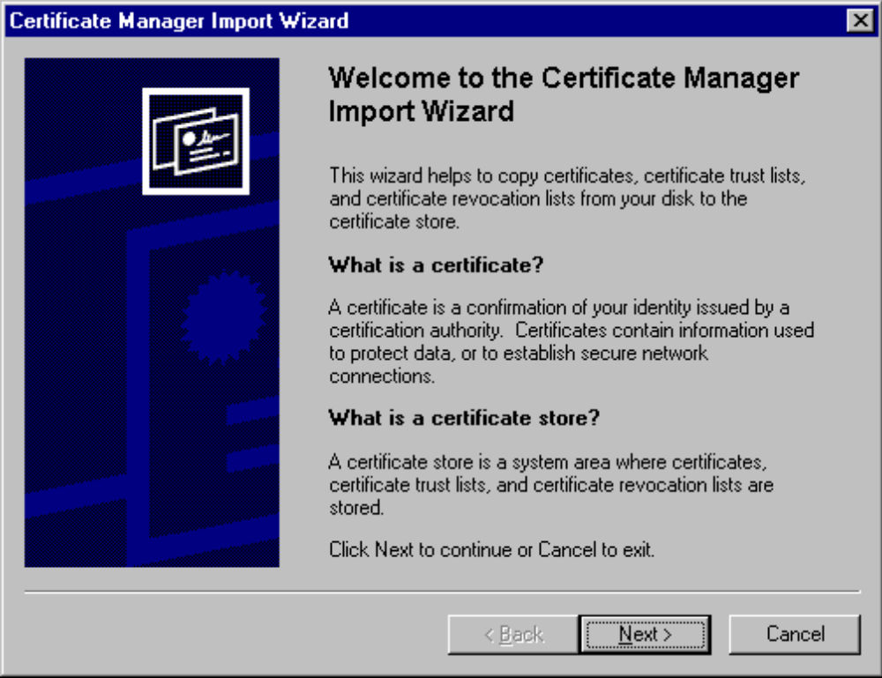

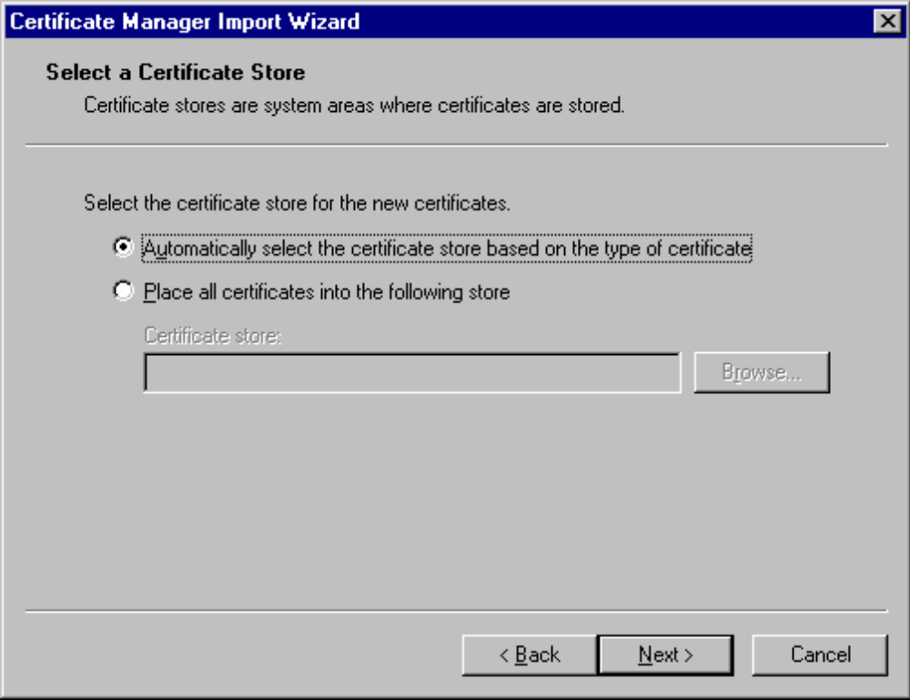
- The following box then appears and “Automatically select the certificate store based on the type of certificate” should already be selected. If it isn’t select it now. Click Next.

- The final Certificate Manager Import Wizard window appears. Click Finish to complete the certificate installation.

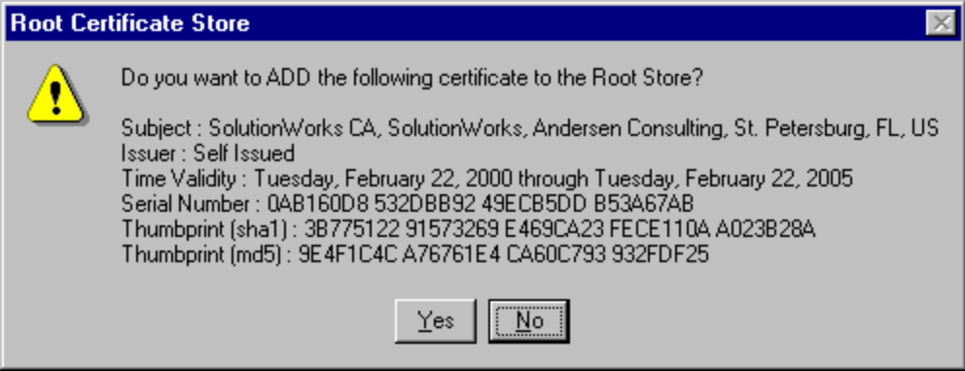
- A Root Certificate Store pop up box appears. Click Yes to accept the certificate installation.

- Once the certificate has been installed, a pop up box will appear informing you “The import was successful.” Click OK.

The digital certificate is now installed on your computer and you should be able to access the portal.

B. Log in to the portal
Note: The ERCOT portal release 2 can only be accessed with Internet Explorer 5. Ensure that you have this version loaded on your computer before attempting to access the portal.

Once you have installed the digital certificate, you can now access the portal. Follow these steps:

- Open Internet Explorer 5 from your desktop

- Enter the following address in the address field at the top of the screen:

https://portal.texaschoiceprogram.com

Note: Enter the address exactly how it appears above without any spaces or capital letters. Ensure that the prefix you enter is ‘https’ not ‘http’.

A security access popup box will appear.
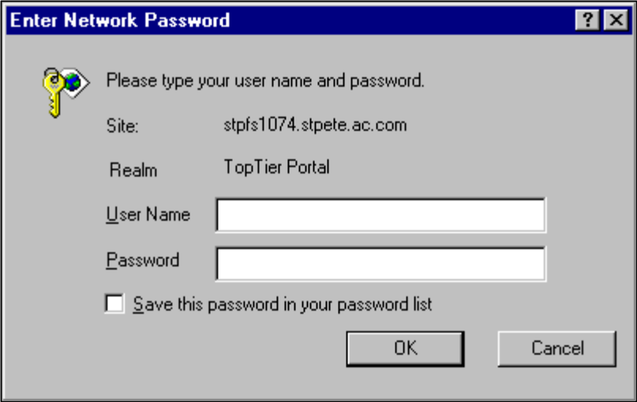
- If you are logging in as ERCOT, log in using the following information (Note: the login security is case sensitive so
ensure that you type your User Name and Password exactly as they appear below):
- In the User Name field, type “ercot”
- In the Password field, type “ercot”
- Click the OK button.

If you are logging in as a QSE, log in using the following information (Note: the login security is case sensitive so ensure that you type your User Name and Password exactly as they appear below):
  - In the User Name field, type “qse”
  - In the Password field, type “qse”
  - Click the OK button.

If you are logging in as a REP, log in using the following information (Note: the login security is case sensitive so ensure that you type your User Name and Password exactly as they appear below):
- In the User Name field, type “rep”
- In the Password field, type “rep”
- Click the OK button.

If you are logging in as PUCT, log in using the following information (Note: the login security is case sensitive so ensure that you type your User Name and Password exactly as they appear below):

  - In the User Name field, type “puct”
  - In the Password field, type “puct”
  - Click the OK button.

The ERCOT portal will now appear on your screen.

Note: If this is your first time logging in to the site, a window will appear telling you that the site you are viewing contains both secure and non-secure items. As well, windows may appear asking if you want to load or run ActiveX Controls on your computer. Click Yes to each window containing these messages and the ERCOT portal will appear.

